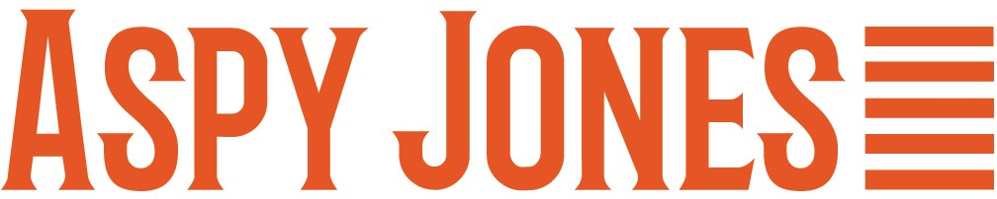
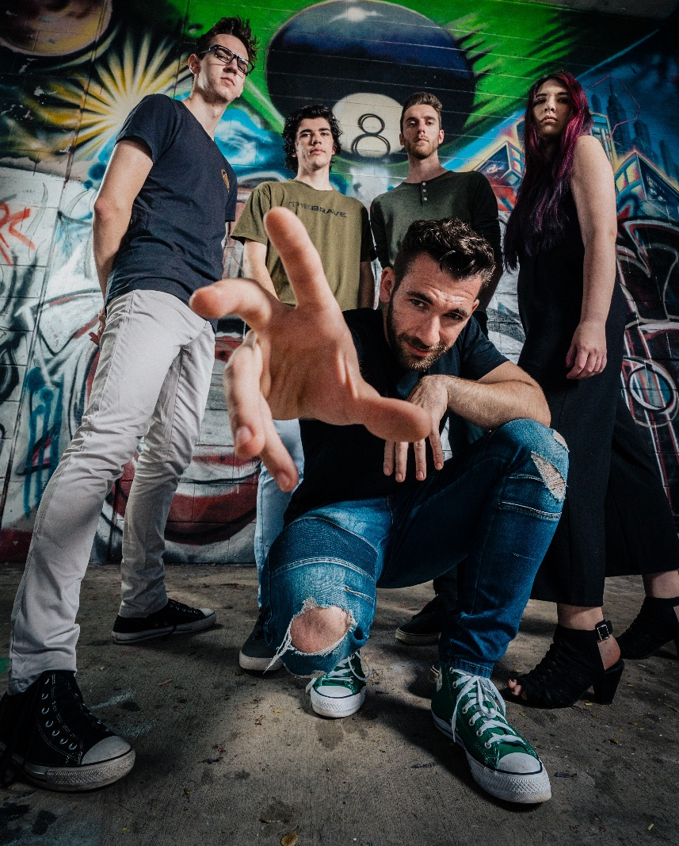 | Aspy Jones is a prolific songwriter from regional Queensland. He writes tunes about his unique perspective on life, good mental health and the difficulties he’s faced as he’s learnt to live with autism and anxiety. While his songs reflect a quirky sense of humour and a keen eye for unusual detail, they are also real and authentic. His five-piece band, which includes two of his siblings, perform their eclectic mix of original roots/pop sounds around SE Queensland while advocating for more inclusion of disability within the music industry.  This 24-year-old is fresh out of the studio where he has been recording and working with ARIA award-winning producer Paulie Bromley and Steve Summers at the amazing Yama-Nui Studio in the Sunshine Coast hinterland and he’s keen to unleash his new music in 2022.

Aspy Jones has been writing, busking and gigging with his original songs since he was 16. He has won several competitions including Battle of the Rising Stars at the Noosa Surf Club, AICM Band Showdown with the Gympie Music Muster, Talent Search at the Rockhampton River Festival and he also won a 4-track EP recording with Pacific International Music at Hervey Bay Unplugged.
Aspy Jones and his lively, family band have supported The Fabulous Caprettos (Daryl Braithwaite, Russell Morris, Rai Thistlethwaite and Jack Jones) at the Sunshine Coast’s Nightquarter. They have also entertained crowds at Gympie Music Muster, Mitchell Creek Rock and Blues Fest, Undercover Artist Festival, Queensland Music Festival, Rockhampton River Festival, Hervey Bay Seafood Festival, Rush Festival, Hot 91 Fire in the Sky, Peregian Originals, supported The X Factor’s, Dean Ray and Taylor Henderson and were showcased at the Sunshine Coast Annual Regional Music Conference, Turn Up. Aspy has been at the top of the Triple J Unearthed Charts many times with his previous releases and has also been fortunate to be awarded grants for recording new material from RADF and Arts Queensland. If you haven’t been following his journey, now is the time to find out more.
Spotify:  https://open.spotify.com/playlist/5CQ406OomjWqSnFjsnTeGD?si=c6a7490d7fea459c  Facebook:  https://www.facebook.com/aspyjones  Instagram:  https://www.instagram.com/aspyjones  YouTube:  Aspy Jones Music Videos - YouTube | Contact Aspy Jones  Website:  https://www.aspyjones.com/  Email: aspyjones@gmail.com

